Experiment 1

1.Install and configure PHP web server

Aim: Install and configure PHP web server

Solution:

Download XAMPP for Linux
Head over to this website to https://www.apachefriends.org/index.html XAMPP. You’ll notice three download options for different platforms: Windows, Linux, and OS X. Click the middle option “XAMPP for Linux” and the download will start.
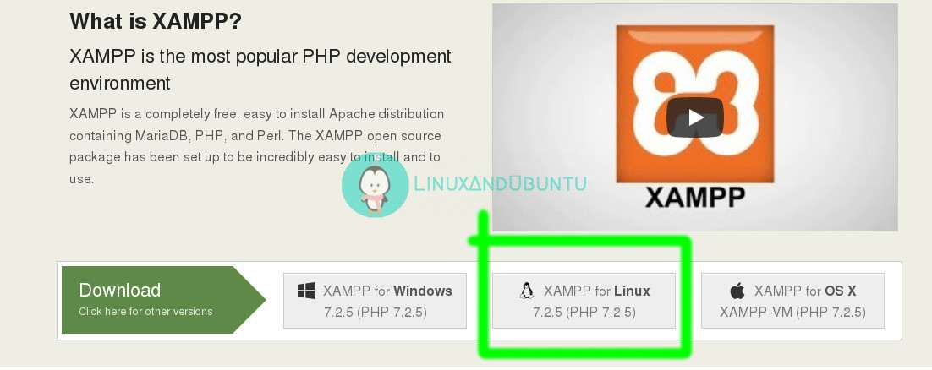
On a side note, since XAMPP can be installed on Windows and OS X too, this creates an excellent opportunity (in case you’re a pupil) to collaborate on a project with your Windows or OS X peers together.

Installing XAMPP On Linux
After you’ve downloaded XAMPP installation file, open a terminal program and browse to the directory where you downloaded the file. Usually, it’s in the Downloads folder so the below command would work on all Linux platforms unless you customized the download location yourself:
cd ~/Downloads
Change the file mode to executable:
chmod +x xampp-linux-x64-7.2.5-0-installer.run
Then using sudo, execute the xampp installation file to install it on your computer:
sudo ./xampp-linux-x64-7.2.5-0-installer.run
cd ~/Downloads
Change the file mode to executable:
chmod +x xampp-linux-x64-7.2.5-0-installer.run
Then using sudo, execute the xampp installation file to install it on your computer:
sudo ./xampp-linux-x64-7.2.5-0-installer.run

Launching XAMPP
After installation, you might have clicked Finish by leaving the Launch XAMPP option ticked (and it’ll launch). But unlike usual applications on your computer where you just launch them by point and click, XAMPP has no .desktop files, you’ll have to launch it using a terminal emulator program. Also, XAMPP requires root privileges in order to be run successfully.
Launch a terminal program, then change your current directory to /opt/lampp and execute the below command to start xampp sudo ./manager-linux-x64.run After that, turn on Apache web Server on the Manage Servers tab and then launch your favorite web browser. On the URL bar, load this page http://localhost.com or http://127.0.0.1, you’ll notice the similar output as shown in the screenshot below.
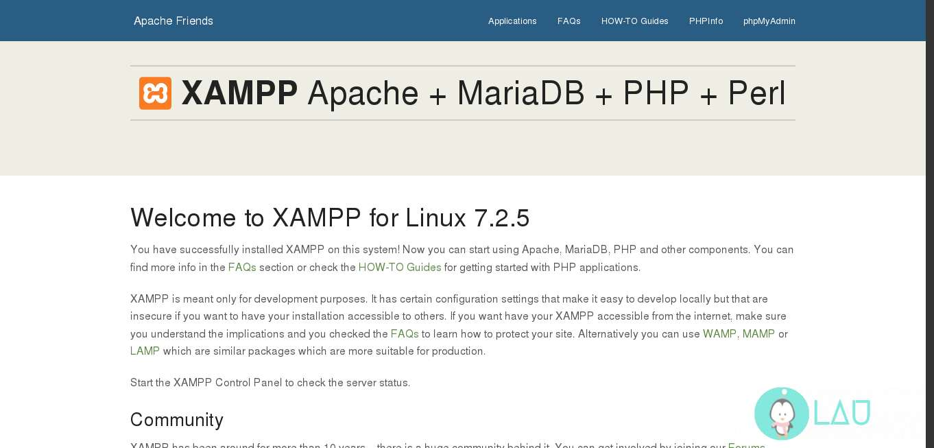
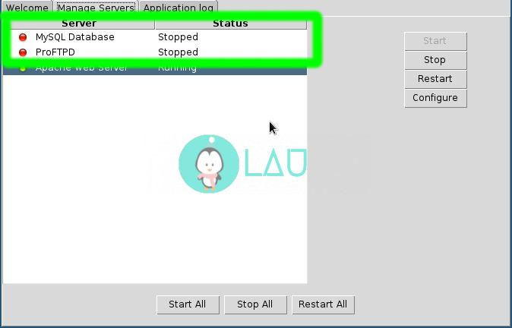
Conclusion:
We’ve successfully set up XAMPP and got it working! we can use it to test your PHP scripts or play around with MySQL. we can develop and test our web app before deploying it.

2.WAP to print message “welcome to PHP”
Aim: WAP to print message “welcome to PHP”
Defination:
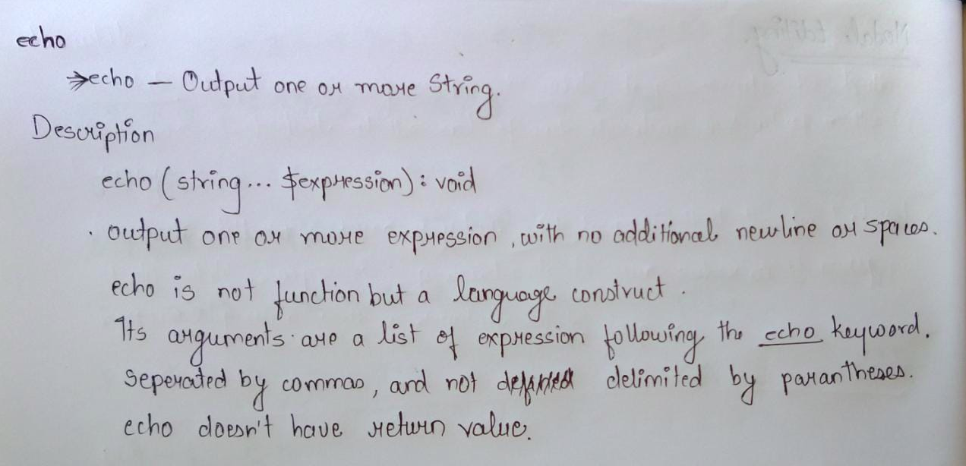

Code:

<?php
echo "welcome to PHP";
?>

Output:

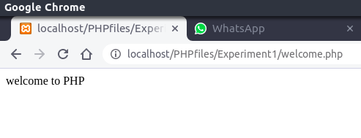

Conclusion:
we have successfully compiled the code for printing “welcome to PHP”
using echo using Xammp server

3 WAP PHP program using operators(bit wise )and Expression

Aim:
Defination:
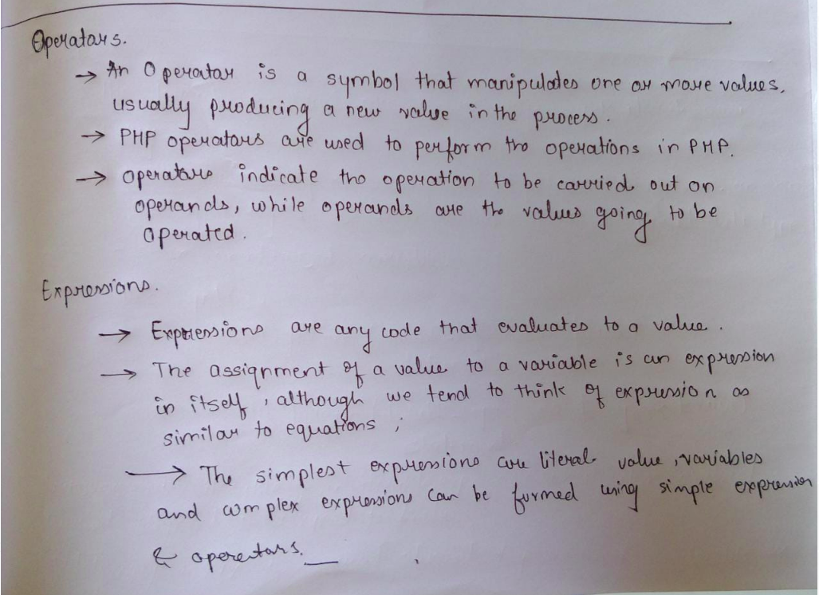
Code:

<?php
// PHP code to demonstrate Bitwise Operator.

// Bitwise AND
$First = 5;
$second = 3;
$answer = $First & $second;

print_r("Bitwise & of 5 and 3 is $answer<br/>");

print_r("\n");

// Bitwise OR
$answer = $First | $second;
print_r("Bitwise | of 5 and 3 is $answer<br/>");

print_r("\n");

// Bitwise XOR
$answer = $First ^ $second;
print_r("Bitwise ^ of 5 and 3 is $answer<br/>");

print_r("\n");

// Bitwise NOT
$answer = ~$First;
print_r("Bitwise ~ of 5 is $answer<br/>");

print_r("\n");

// Bitwise Left shift
$second = 1;
$answer = $First << $second;
print_r("5 << 1 will be $answer<br/>");

print_r("\n");

// Bitwise Right shift
$answer = $First >> $second;
print_r("5 >> 1 will be $answer<br/>");

print_r("\n");
?>

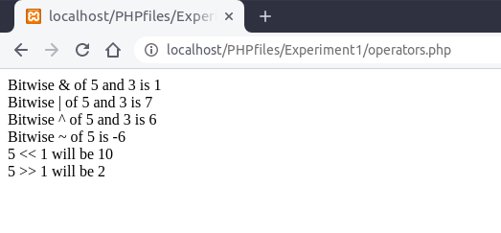
Output:

Experiment 2
1.Print message “welcome TO PHP” by using if statement
Aim:
Defination:
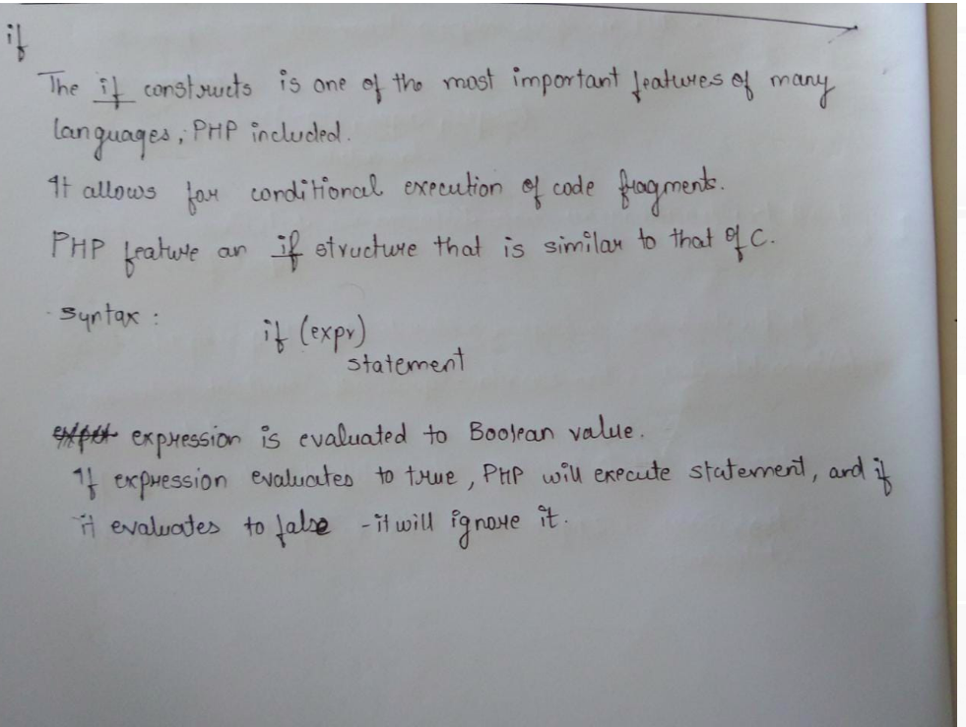
Code:
<?php
$user="name";
if ($user=="name")
{
echo"welcome to PHP";
}
?>
Output:
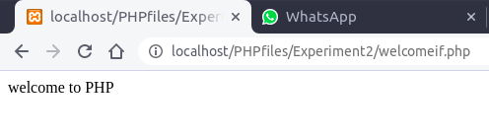

2 WAP to check whether number is divisible by 9 or not using
if-else
Aim:WAP to check whether number is divisible by 9 or not using
if-else
Defination:
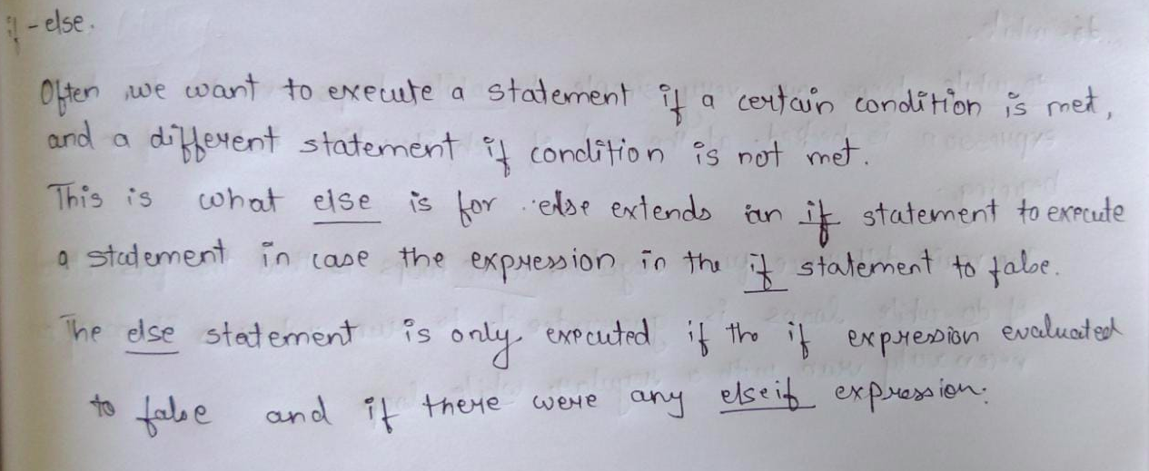
Code:
<?php
echo "welcome<br/>";
$number=90;
if($number%9==0)
{
echo"YES ".$number." is divisible by 9<br/>";
}
else
{
echo"NO ".$number." is not divisible by 9<br/>";
}
?>
Output:

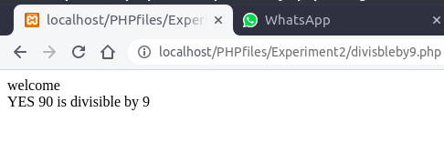

3 Any program using switch case
Aim:
Defination:
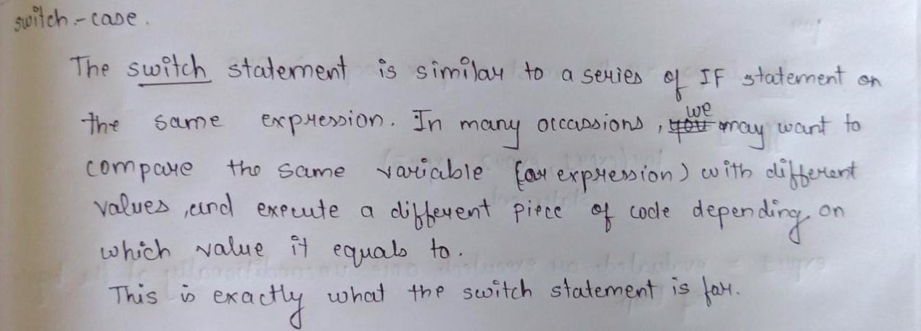
Code:
<?php
$day="Tue";
switch($day)
{
case "Sun":
echo "Today is Sunday";
break;

case "Mon":
echo "Today is Monday";
break;

case "Tue":
echo "Today is Tuesday";
break;

case "Wed":
echo "Today is Wednesday";
break;

case "Thus":
echo "Today is Thusday";
break;

case "Fri":
echo "Today is Friday";
break;

case "Sat":
echo "Today is Saturday";
break;
default :
echo "Something is wrong";
}
?>

Output:

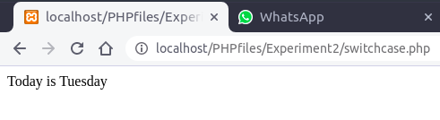

Experiment 3
1 WAP to print number in reverse order using while loop
(number=1234 output=4321)
Aim:
Defination:
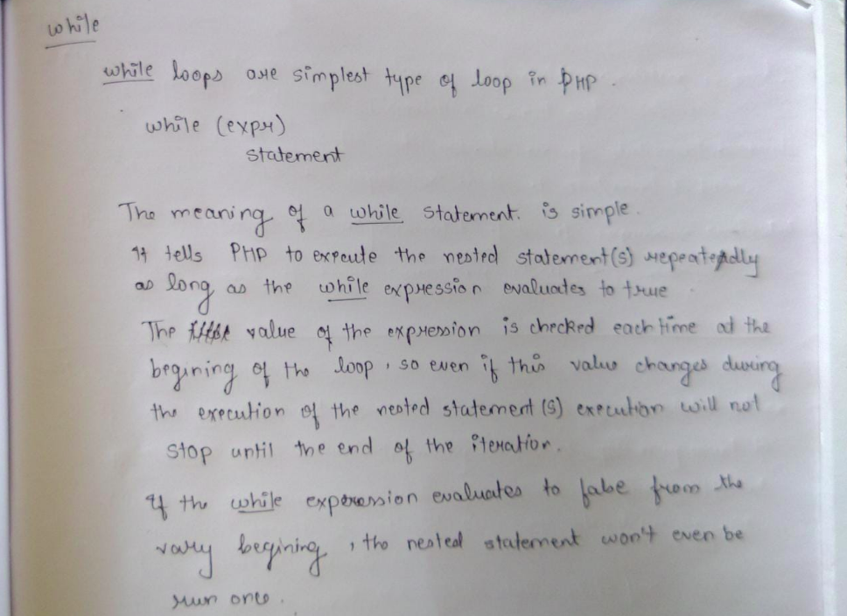
Code:
<?php
$num = 1234;
$revnum = 0;
while ($num > 1)
{
$rem = $num % 10;
$revnum = ($revnum * 10) + $rem;
$num = ($num / 10);
}
echo "Reverse number of 1234 is: ". $revnum;
?>
Output:
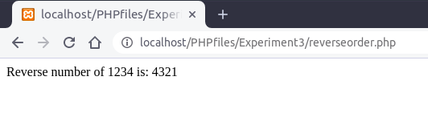

2 WAP to find factorial of a number using for loop
Aim:
Defination:
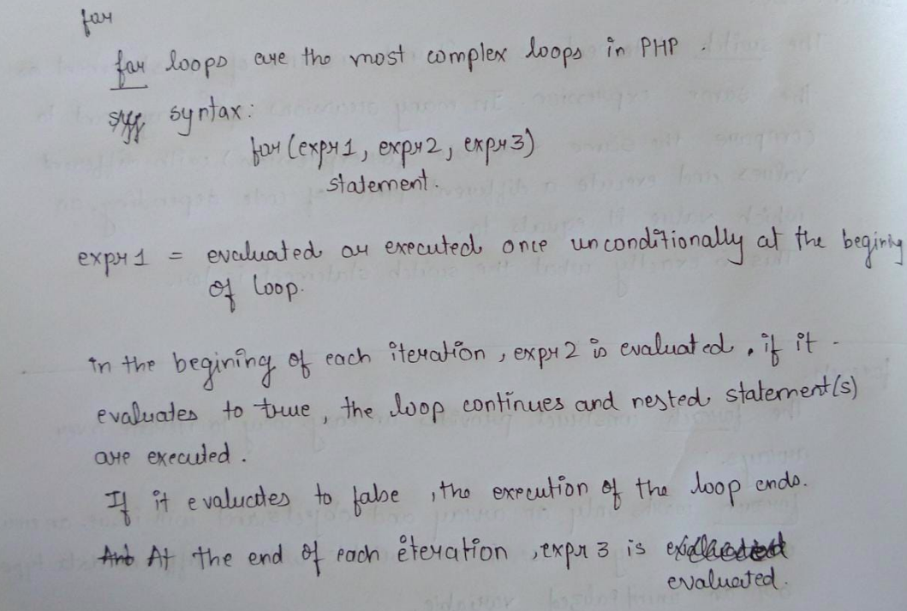
Code:
<?php
$num = 4;
$factorial = 1;
for ($x=$num; $x>=1; $x--)
{
$factorial = $factorial * $x;
}
echo "Factorial of $num is $factorial";
?>
Output:

3.WAP to print no 1 to 10 using do-while
Aim:
Defination:
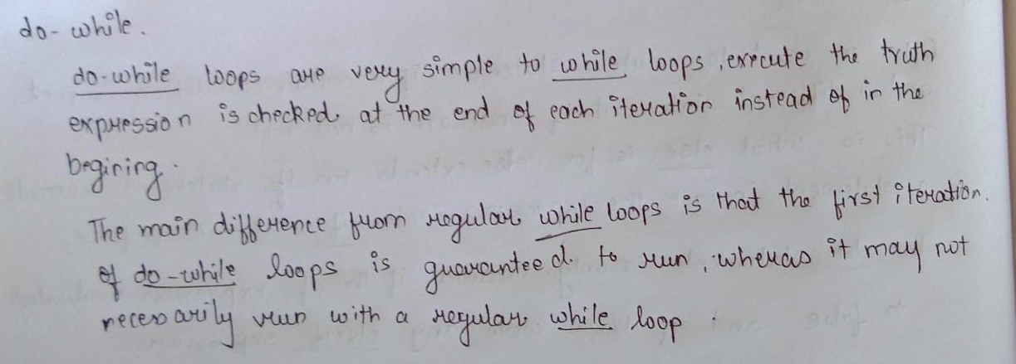
Code:
<?php
$i=1;
do {
echo $i."<br/>";

$i++;
}
while($i<11);
?>
Output:

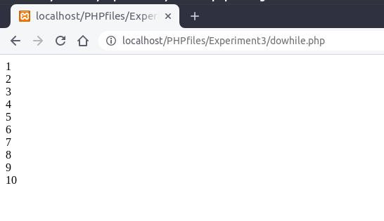
4) WAP using foreach and display array elements
Aim:
Defination:
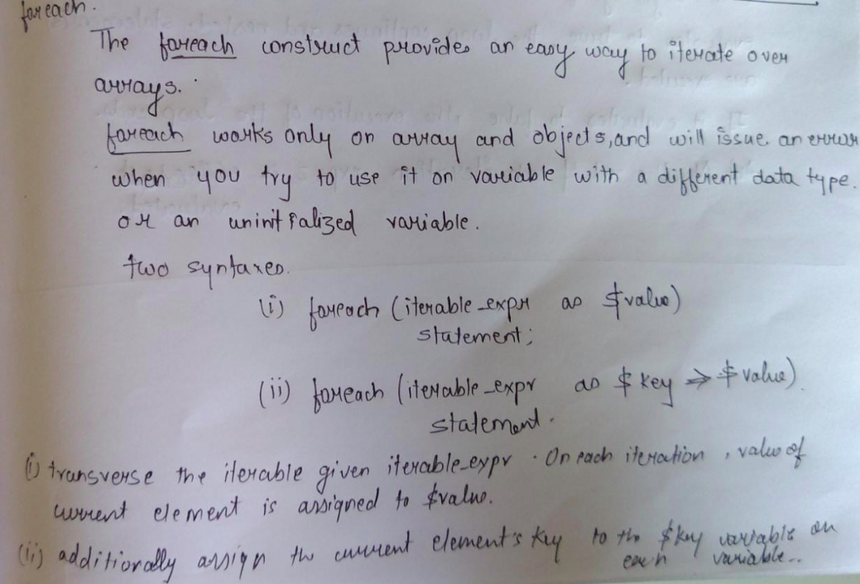
Code:
<?php
$arr=array(1,2,3,4,5);
{
foreach ($arr as $value)
echo $value."<br/>";
}
?>
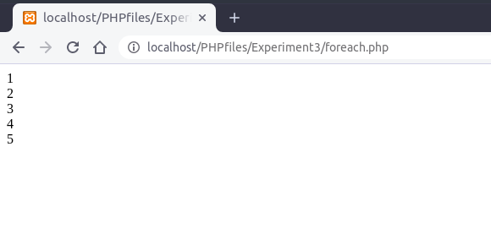
Output:

